C:\Users\traecit2\Desktop\excelsoft_logo.png

***CREATING RESOURCE GROUP IN AZURE***



| Document Details | |
| --- | --- |
| Type Of Information | **Document Data** |
| Document Title | Creating a Resource Group in Azure |
| Document Reference Number |  |
| Document Owner |  |
| Security Classification |  |
| Review Frequency |  |

| Document Approval | | | |
| --- | --- | --- | --- |
| Name | **Role** | **Signature** | **Date** |
| Mahesh Jambardi | Chief Operating Officer | Mahesh Jambardi |  |
| Srinivas Chudamani | Sr. Manager IT & IS Infrastructure | Srinivas Chudamani |  |

| Version Control Details | | | |
| --- | --- | --- | --- |
| Version  Number | **Revision Date** | **Prepared by** | **Nature of Change** |
| 1.0 |  |  |  |
| 2.0 |  |  |  |
| 3.0 |  |  |  |
| 4.0 |  |  |  |
| 4.1 |  |  |  |
| 4.2 |  |  |  |
| 4.3 |  |  |  |
| 5.0 |  |  |  |

**Table of Contents**

[**1.**](#_heading=h.30j0zll)  **4**

[**2.**](#_heading=h.2et92p0)  **4**

[**2.1.**](#_heading=h.tyjcwt)

[**3.**](#_heading=h.lnxbz9)  **9**

[**3.1.** 9](#_heading=h.35nkun2)

[**4.**](#_heading=h.1y810tw) **REFERENCE 11**

**Steps:**

# **Sign in to the**[**Azure portal**](https://portal.azure.com/)**.**

Search for  **Resource groups**.

Select Create.

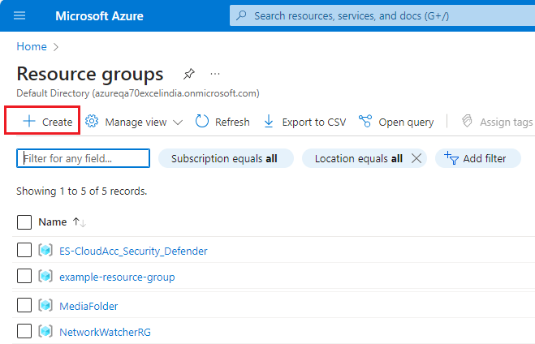

1. Enter the following values:

**Subscription**: Select your Azure subscription.

**Resource group**: Enter a new resource group name.

**Region**: Select an Azure location, such as **EAST US**.

Click **Review + Create** 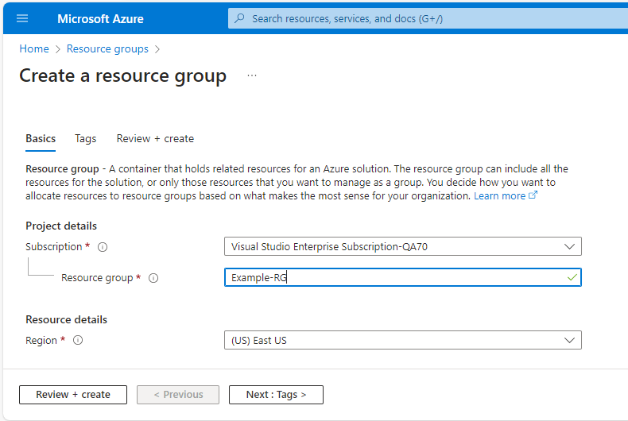

1. Select **Create**. It takes a few seconds to create a resource group.

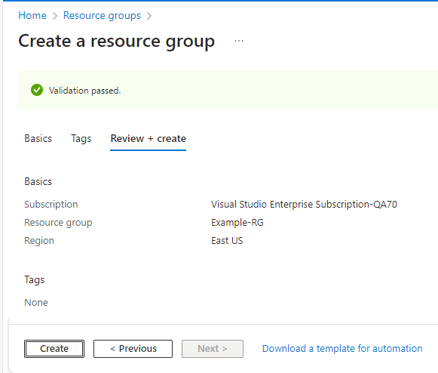

1. Select **Refresh** from the top menu to refresh the resource group list, and then select the newly created resource group to open it. Or select **Notification**(the bell icon) from the top, and then

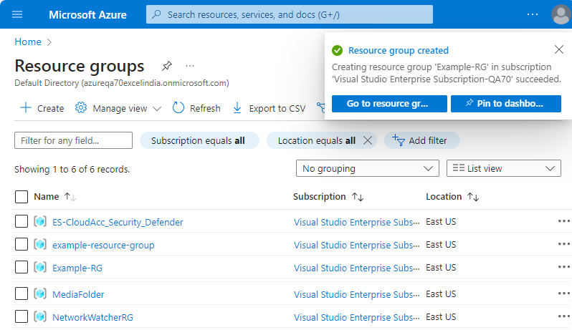

1. Select **Go to resource group** to open the newly created resource group

# 